NORTH YORKSHIRE THRIVING COMMUNITIES PARTNERSHIP
CO-PRODUCTION AND COMPACT CONTEXT PAPER

Introduction
This paper gives background context for the Thriving Communities Partnership meeting, focussing on collaborative co-design and system leadership as key enablers within progressive commissioning and procurement.

- North Yorkshire and Co-design and Co-production
In 2019 the North Yorkshire Public Health Director’s Report focussed on tackling poverty and highlighted the value of
‘working with people and communities to create a shared future is more effective than doing things for them or to them. This principle is supported by a growing body of evidence that community participation leads to sustainable poverty reduction, especially where attention is given to training and building capacity in the community. Social networks and approaches that seek to build social capital in communities can increase the resources available to people to tackle the problems they face. The aspiration of working with communities is to design, reshape and deliver services equally with those who use them to create better outcomes.’

This approach is summarised below and is now being advocated by central government and the NHS organisations as a progressive way of making the most of all assets available within and across places. Collaborative, strengths based commissioning is also being increasingly advocated by NHS England
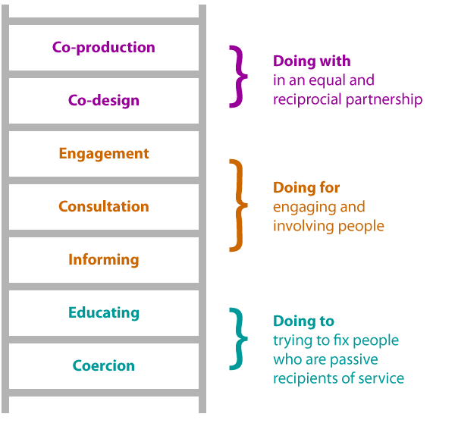
In July 2021 a North Yorkshire workshop was organised by Community First Yorkshire to explore how charities, people with lived experience and public sector colleagues can support the development of more community based solutions for people experiencing mental illness, using co-production.

The workshop participants identified the key values/principles, enablers and impact considerations that support true co-production, these are summarised in Appendix A.

This has resulted in the new North Yorkshire Co-design Network which meets monthly online as a community of practice funded through the Community Mental Health Transformation Programme.
In January 2022, North Yorkshire County Council (NYCC) published its report - Options appraisal: voice and representation of people with lived experience of mental health services
‘Why would you design and implement a service without the valuable input of the very people who need it and use it – these are the experts by experience?’

ThriveLab was commissioned to look at how NYCC could engage and involve people with lived experience (LE) of mental health services, so that they can make sure that the design, delivery and evaluation of services meets the needs of people using them. NYCC staff and providers and wider health system partners. The groups were asked what their ‘best hopes’ were for lived experience of mental health voice and representation. They were that:
  - True co-production and engagement are built on terms agreed by people with LE
  - Lived experience voice and representation helps to address health inequalities through diversity and place
  - We must support the ongoing development of future LE contributors and leaders.

For these hopes to be achieved, the following conditions need to be created:
- Capacity – the model needs to be properly and jointly resourced at every stage
- Asset based – identifying and building on the strengths of LE individuals and organisations
- Place based – recognising and supporting a wide range of LE voices from all localities
- Relationship building – build networks of LE practice, helping them to flourish through regular human contact
- Practical – any new LE group should be supported to take on realistic, achievable projects as it grows
- Impact – evaluation must be robust, people with LE are supported to build an evidence base of the impact of interventions.
- Influence – ability to affect genuine change, which can be measured and communicated
- Independent vehicle – encouraged from the outset, with greater independence sought over time.

- Working Together – System Leadership and North Yorkshire Compact
The North Yorkshire Compact defines the relationship and partnership between public sector organisations and voluntary, community and social enterprise organisations

The Compact Framework aims to strengthen existing relationships. It outlines specific commitments and undertakings for the public sector and VCSEs, for each of the following outcomes:
- A strong and diverse and independent civil society.
- Effective and transparent design and development of policies, commissioning, programmes and public services.
- Responsive and high- quality programmes and services.
- Clear arrangements for managing changes to programmes and services.
- Improved community health and wellbeing.
- An equal and fair society.

Development of system leadership structures and working practices provides a mechanism to refresh the Compact. This could include, for example, creating logic models or plans on a page to explain why change is needed and how different activities are intended to bring about that change. The Social Care Institute of Excellence Logic Model for Integrated Care, which was developed for the Department of Health and Social Care (DHSC) with the NHS, seeks to capture a complex system into a single page, shown below:

Figure 1 Leadership model of health and care
1990s 2020s
1. Hierarchical
2. Fixed, prescriptive

3. Power-centred
4. Focused on individual organisations
5. Territorial, proprietary, centralised
6. Professional driven

7. Transactional
8. Primarily accountable to regulators and policy-makers
9. Self-centred
10 Short-term, task-orientated

11. Avoids conflict

12. Competitive, conflict-prone

1. Horizontal, multidirectional
2. Adaptive, comfortable with chaos
3. Seeks to influence
4. Place-based, whole system

5. Complementary, diffused, distributed, participatory
6. Person-centred, inclusive, co-productive
7. Relationship-based, personal
8. Primarily accountable to people and communities
9. Altruistic
10 Long terms, focused on transformation of whole system
11. Surface conflicts, solution-focused
12. Consensus seeking, builds a shared vision and narratives

Appendix A - July 2021 Workshop – summary of key values/principles, enablers and impact considerations identified

Values and principles of true co-production
- Parity of esteem - between individuals and organisations with a shared language as equals, building relationships
- Trust - being clear about what all participants want, resources and barriers
- Inclusive - everyone’s contributions are sought and encouraged
- Respect - everyone’s contributions are valued and recognised
- Open to change - it is acknowledged that things are likely to develop and change.
- Accessible - all needs are catered for, with time and space to reflect
- Agile - working in flexible ways that encourage new ideas to be explored
- Aware - realistic about what can be achieved, but supportive of challenge
- Communication – ensure change is captured and communicated clearly

Enablers of true co-production
- Safety - everyone involved feels able to share and contribute as they wish
- Consistency - agree joint expectations from the outset, sense checking along the way
- Resources - sufficient investment of time, appropriate materials and communication
- Clarity - jargon free, purpose and outcomes are understood by everyone
- Quality – focus on outcomes not just outputs, the experience of working together itself is important
- Location –in a place where people feel comfortable
- Scale - relevant to those participating, practical and realistic
- Openness – willingness to listen and accept fair criticism/challenge
- Shared ownership – make it everyone’s role to promote and encourage involvement
Impacts – what can/could be measured in a meaningful way?
- Measure what matters – not just driven by funders/commissioners, ask people what matters to them in each locality, be creative in how and what we measure.
- Quantitative - reduction in complaints, increased satisfaction (staff and users of services), continuous involvement (tracking of journeys), more ideas coming from users of services, getting it right first time.
- Geographic/demographic – improvements tracked between areas and communities
- Qualitative – truly person-centred services, shifting expectations of individuals and organisations so that service users feel the service is appropriate for their needs.
- Protected characteristics - clear input and influence from individuals and communities from these groups
- Separation of practice and outcomes – measure both outcomes/impact of the work and the quality of the co-production process itself
- Learning capture – reflective practice built in as a measurable outcome
- Flexible/adaptive/agile – responding to feedback, with explicit permission to fail and learn from failure.
- Monitoring and evaluation framework – co-produced/owned by people with lived experience
- Range of opportunity – increased participation due to variety of access and methods

