North Yorkshire Thriving Communities Partnership Meeting
Monday 7th March
Notes of meeting

Attendance:

Abigail Barron, NYCC
Ann Duncan, Harrogate BC
Barbara Merrygold, NYCC
Bryony Boyle, Selby Big Local
Caroline O'Neill, Community First Yorkshire
Claire Lowery, NYCC
Claire Robinson, Carers Plus
David Watson, North Yorkshire Sport
Dave Winspear, North Yorkshire Fire & Rescue
David Sharp, NYY
Emma Pears, SELFA
Fiona Bell-Morritt, NHS Vale of York CCG
Jan Garrill, Two Ridings Community Foundation
Jane Colthup, Community First Yorkshire (Chair)
Jo Ireland, Scarborough BC
Jo-Anne Scott, Richmondshire DC
Frances Elliot, HARCA
Leon Fijalkowski, Orb Arts
Liz Lockey, Hambleton Community Action
Louise Wallace, NYCC
Margaret Wallace, Ryedale DC
Marie-Ann Jackson, NYCC
Mark Hopley, Community First Yorkshire
Neil Irving, NYCC
Phil Bramhall, Chopsticks
Rachel Woodward, NYCC
Richard Webb, NYCC
Sam Alexander, Better Connect
Sam Haward, NHS North Yorkshire CCG
Sharon Hudson, Craven DC
Thomas Hirst, North Yorkshire Fire & Rescue

Apologies:

Angela Crossland, Selby
Elizabeth McPherson, Carers Plus
Jill Quinn, Dementia Forward
Lisa Keenan, Ryedale Special Families
Lisa Wilson, Hambleton DC
Max May, Rural Arts
Natasha Almond, North Yorkshire Police

- Public Health Framework – Louise Wallace

Health in North Yorkshire: Life expectancy at birth is 84.4 years for women and 80.6 years for men, both above the England average. However, women and men live 4.8 and 6.9 years longer respectively in the least deprived areas compared with those in the most deprived areas.

Why do we need to change?

- Sir Michael Marmot’s Build Back Fairer – Covid 19 Marmot Review. Inequalities are more visible and extensive as a result of Covid; Government levelling up programme planned
- We need to be fit for purpose to meet the challenges ahead, both as we continue to respond to COVID-19, and address the longer term impact and consequences
- The system around us is changing – from 1st October 2021 Public Health England ceased to exist and was replaced by UK Health Security Agency (UKHSA), the Office of Health Improvement and Disparities (OHID), and some functions being picked up by NHSE/I
- The Health and Social Care White Paper in February 2021 signalled the reorganisation of the NHS leading to greater integration and, from April 2022, the creation of statutory Integrated Care Systems (ICS) and disestablishment of CCGs
- In September Government published “Build Back Better – Our plan for the NHS and Social Care” and Social Care White Paper promised later this year
- Local Government Reorganisation - maximising opportunities in the new authority from April 2023, building on and extending current locality working arrangements across the wider team
- The broadened role and remit of the Director of Public Health provides an opportunity to consider how resources and capacity are deployed across the wider Public Health (PH) and Engagement & Governance Team (E&G)
- Capitalise on the higher profile of Public Health over the last year, both within NYCC and system partners and with the wider public
- The impact of the pandemic means we need to review and refresh how we deliver PH and E&G as part of the “new normal”, whilst still providing PH leadership and a resilient outbreak management response, including dedicated capacity around Health Protection.
- Recommendations from the recent Peer Challenge mean we need to consider and implement learning from the last 18 plus months
- The County Council is reviewing future ways of working, and it’s timely to think about what that means for us

Outcome: Improve and protect health of the people who live in North Yorkshire – adding years to life, adding life to years.

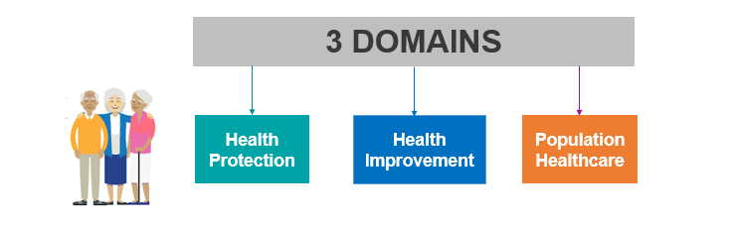

Priorities 2021/22

- Reduce health inequalities, through healthy place shaping and targeted work with vulnerable groups/communities
- Ensure measures are in to protect the populations health
- Improve the mental health of our population
- Ensure babies and children and young people have a good start in life
- Ensure the working age population have opportunities to live well
- Ensure older people are able to age well
- Work with our NHS partners to maximise our joint effectiveness and impact on health outcomes
- Develop a centre for public health excellence including in research, training and behavioural science

The Financial Challenge – PH Grant £23,169,300

- Current gap is £1.3m per annum (allocated budget v grant). Plan to meet this gap.
- Plan strategic use of reserve

Savings, Investment and Transformation

- Service efficiencies in smoking services, sexual health, dental and drug and alcohol services
- Section 75 partnerships for 0-19 and sexual health.
- Maintain investment in stronger communities
- Budget realignment
- Integrate NHS health checks programme with IBCF
- Develop living well offer to include mental health offer.
- Review Infection Prevention Control contracts jointly commissioning with the NHS
- Over next 2 years transform approach to physical activity and obesity including reviewing adult weight management services in light of LGR.

Future developments:
- 10 year drug strategy – new investment coming to Local Government
- Government priority to tackle obesity – national grant
- Transform our approach to getting people moving more - physical activity and sport and maximise investment into the County.
- Develop public health capacity with the NHS – population health management
- Negotiate with UK Health Security Agency and Office for Health Inequalities and Disparities (previously PHE) public health system leadership roles on shared agendas to maximise capacity
- DPH Annual Report 2021/22 – focus on quantifying the public health challenges post pandemic and inequalities that have been extenuated
- Play our part in LGR as a fully integrated part of the new authority

- Sport England system of handing over funding to partners to shape investment – David Watson

The Sport England Board has made a significant commitment to establishing a refreshed portfolio of ‘system partners’, who they know play a range of critical roles across the country, with different audiences and varied activities.

Sport England's decisions on investment are based on the following criteria:

Impact
That the vision, goals and immediate priorities of partners are aligned to Uniting the Movement (the strategy for Sport and Physical Activity in England), and likely to achieve positive change, especially in tackling inequalities.

Collaboration
Of partner's continued commitment to developing and delivering these priorities through collaboration and engagement.

Development
Of partners commitment to continue to improve and develop as healthy, robust and responsive organisations, building on the phase 1 diagnostic tool.

Finance
That Sport England funds will be used appropriately in pursuit of partner’s vision, goals and immediate priorities. This will be demonstrated through a clear budget outlining all the relevant costs and resources required to contribute to the vision, goals and priorities. The budget should also demonstrate that the funding is clearly aligned to Uniting the Movement.

Having completed an initial phase that demonstrated our alignment to the Uniting the Movement Strategy, North Yorkshire Sport has been established as a Systems Partner and as such Sport England ‘allocated’ a maximum amount of funding that we could apply for over a five year period.

Reflecting and building on the role identified during ‘Phase 1’ (Systemic, Governance Delivery and Talent), Sport England asked us to articulate:

VISION, GOALS AND CHANGE

- Our long-term vision: the single overarching vision of what we want to achieve through each of the identified roles particularly in relation to tackling inequalities and Uniting the Movement.
- Our medium-term goals: The headline goals that we intend to work towards for each role over the next investment period that will help achieve the change outlined in Our vision, to tackle inequalities, and support Uniting the Movement.
- Our short-term initial steps: These are the initial milestones that we need to reach on the journey towards our vision and goals to help us tackle inequalities and to support Uniting the Movement.
- The change we want to create: What success looks like in the context of the vision and goals, especially around tackling inequalities and Uniting the Movement.

Sport England provided a template for this which we completed, discussed with a link officer and then submitted to the Sport England Board who approved the plan and the investment for 5 financial years.

The investment is for the Systemic Role and separate from any additional delivery/programmes we may carry out on their behalf in the county.

- Co-design, co-production and collaboration– learning from approaches - Mark Hopley

- See paper

- Sport North Yorkshire Care Market Overview – Abigail Barron

Transformation Vision
- A focus people and their outcomes
- The person remaining as independent as possible and living in their own home for as long as possible
- Focus on prevention and alternative provision for complex needs and switching away from residential homes and nursing beds
- Frontline colleagues excelling at strengths-based practice, being empowered to be creative
- Organisation interfaces working seamlessly together and not being visible to people we support

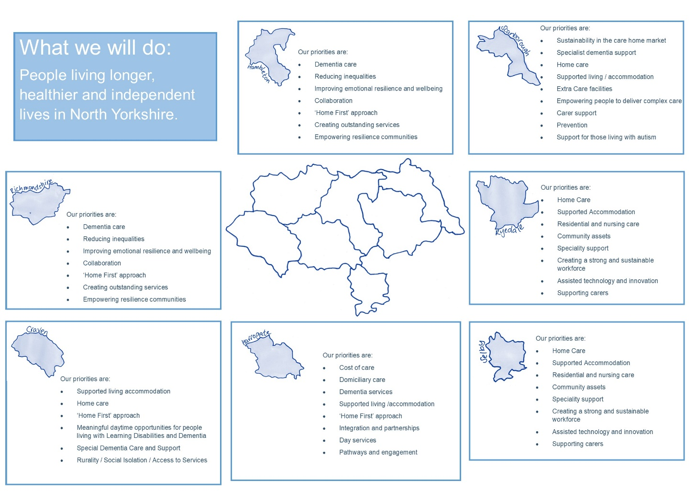

Service Development Transformation Programme

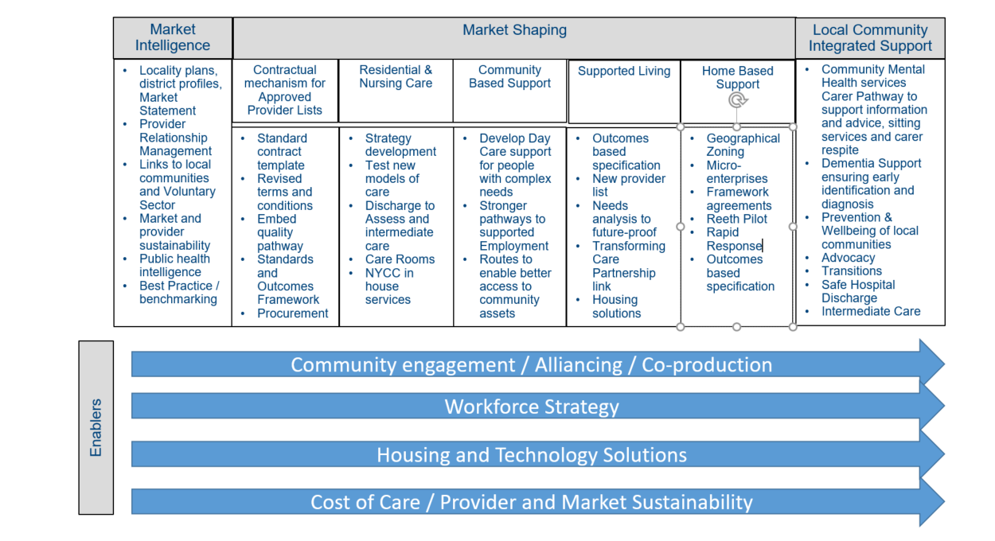

- Discussion

Building on what we have
- building on what already there
- communities assets – not just buildings
- knowledge of place
- skills
- review of North Yorkshuire Compact

New council will bring opportunities
- place and wellbeing
- equality and social value
- opportunity to use cultural assets to reduce health inequalities
- day one safe and legal, change will likely happen two years later
- housing / social care / leisure / public health in one organisation

Issues
- Need for longer terms stability for VCSE, care providers
- Cost of living
- Systems different across county – ICSs at different levels of development
- Need to ensure good value for money

New ways of working
- building on covid – accepting increased risk
- move to co-production, improved partnership but more chaotic
- longer term funding
- leveraging extra funding into county
- unlearning how things are done
- opportunities for collaboration / partnering
- investment in place
- shared values / honesty
- clarity of what trying to achieve as a system
- how deal with core funding differently

- Next steps

- Carry on conversation, meeting act as catalyst for conversation
- Next meeting in person?

Action – If anyone has other examples of how things are done differently elsewhere send to Claire/Caroline for sharing with the group
Action - Any objections to next meeting being in person feedback to Claire/Caroline

