**Please note that interventions delivered with Multiply funding need to be additional and differentiated from that which is already fully funded through the Adult Education Budget (AEB) legal entitlement and should not displace that provision**. (this is why we asked question in survey so hopefully this should give us perspective on this:

1. Courses designed to increase confidence with numbers for those needing the first steps towards formal numeracy qualifications. Research on skills vacancies, LEP data and the schools data as far back as we can get it

Across North Yorkshire as a whole, the outcomes in maths at KS4 has historically been stronger than national. However, at a more localised level, pupil’s taking their GCSEs in Scarborough consistently fall short of the national average – indicating a considerable gap in maths skills amongst young adults in Scarborough.

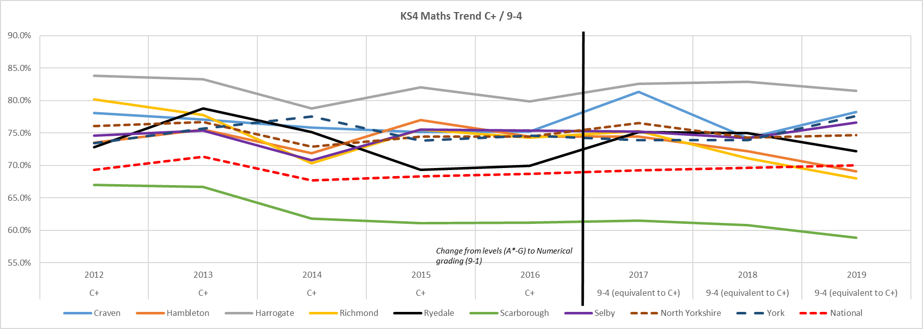

Whilst across the YNY LEP is ranked second in the north in the proportion of people qualified to at least level 2, at a district level, the need for localised ‘levelling up’ is clear, with Ryedale and Selby all lagging behind the national rate in terms of 16 to 64 year old qualified to NVQ Level 1 or higher. Scarborough just hits the national average, whilst all other areas have notable higher rates than the national average.

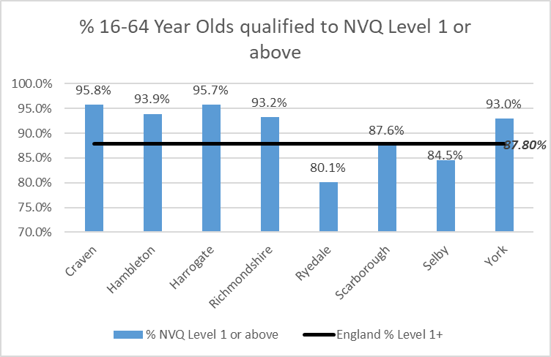

Reflected below, in terms of any Qualifications, of the YNY LEP area, Ryedale, Scarborough and Selby all have notably higher rates, with Ryedale peaking at 13% of 16-64 year olds having no Qualifications, followed by Selby at 10.1% and Scarborough at 9.2%. It is well recognised that qualifications are a key indicator of social mobility – and therefor a lack of qualification amongst a considerable proportion of the populations has significantly restricted social mobility.

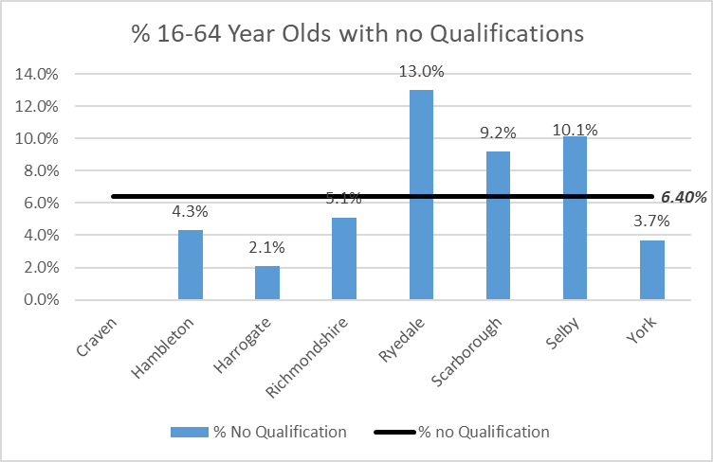

Looking at the wider picture, the Indices of Multiple Deprivation looks at a number of areas, including Education, which measures the lack of attainment and skills in the local population. Overall, whilst a majority of districts (inc. York) in the LEP have an average rank in the lowest (‘best’) half nationally, Richmondshire falls slightly short of the ‘mid-point’ with an average rank of 151 out of 317 districts/boroughs. Scarborough, however, is significantly lower, ranked 59 with 17% of neighbourhoods in the 10% most deprived nationally in terms of education and skills.

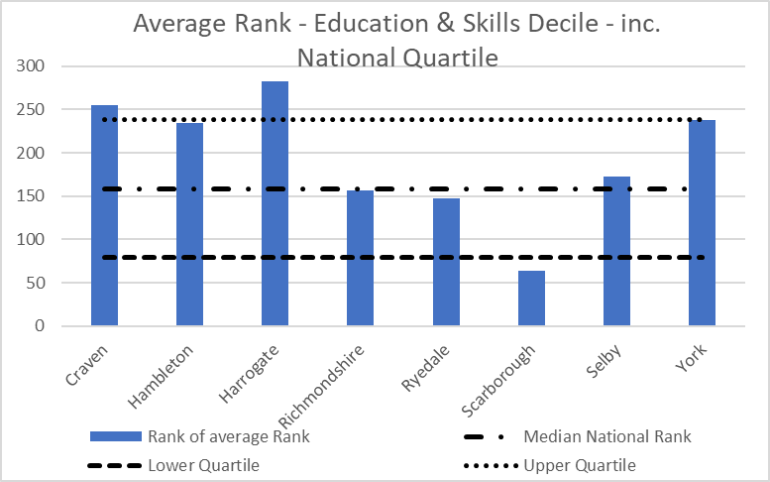

In terms of access to Numeracy Courses, there is some correlation between the areas with the highest rank in terms of Education, Skills & Training (such as Richmondshire & Scarborough) and enrolment in Numeracy Courses offered through ALSS. The chart below shows the average number of enrolments by district since 2018/19. The addition of Functional Skills through the Multiply funding, particularly targeting the areas of high need, such as Scarborough and Richmondshire, will help to close the ‘gap’ in terms of access to education, skills and training through providing the potential missing link.

1. Courses designed to help people use numeracy to manage their money. – research on poverty levels, low wage, debt charity usage, cost of living , foodbank use etc.

Current headlines focus on price inflation not seen in 30 years and, at the end of February, inflation as measured by the Consumer Price Index (CPI) sat at 6.2%. The Bank of England forecasts that inflation will "rise to around 8% in spring and perhaps even higher later in the year" and its own forecasts suggest inflation is not expected to fall to the 2% target until late 2024 at the earliest. Inflation is set to outstrip earnings growth and working-age benefits increases in the short and medium term, meaning family budgets will come under increasing pressure; on average, this will equate to around a 5%-6% fall in real terms in household earnings between now and mid-2023. The Institute for Fiscal Studies highlights that the most vulnerable will face greater inflationary pressures than the more affluent. Those least affluent in terms of earnings are likely to face inflation approaching 9% by April, compared with just over 7% for the most affluent.

An additional cost pressure facing families is rising energy costs. Office of Gas and Electricity Markets (Ofgem) recently announced details of the revised price cap to take effect from April, which will increase the average bill by around £700 to almost £2000 per year. Analysts expect a further increase of 20% in October. Research from the Joseph Rowntree Foundation suggests that working-age, low-income families with children face the prospect of the proportion of household income after housing costs that are spent on gas and electricity rising by at least 6%, and up to 10%, in the coming months. Short-term measures introduced by the Government will offset some of the impact of rising energy prices, although it is as yet unclear how these measures will be delivered to households that are either (a) using a pre-payment meter and (b) not currently paying Council Tax (for example, tenants in a House of Multiple Occupation) or (c) new renters taking a tenancy and electricity supply after October 2022.

Further to this, headlines as of 11th May 2022 are predicting that more than 250,00 households will “slide into destitution” over the coming year, with the poorest families being hit the hardest by the cost of living crisis. With little help being offered currently by central government to ease the impact of spiralling inflation, functional maths skills offers an opportunity for families to better understand setting household budgets and managing their finances.

Whilst North Yorkshire and York and generally viewed as affluent areas, there are pockets of deprivation across all areas. The map below show the deciles of deprivation by LSOA for York (shown in 2 decile groups) and York (shown by single decile) with a dark red representing higher levels of deprivation. These areas, particularly on the Coast and North & South of the Moors, in central Harrogate, Selby and Central and Eastern York are particularly vulnerable in terms of the impact of the rising cost of living.

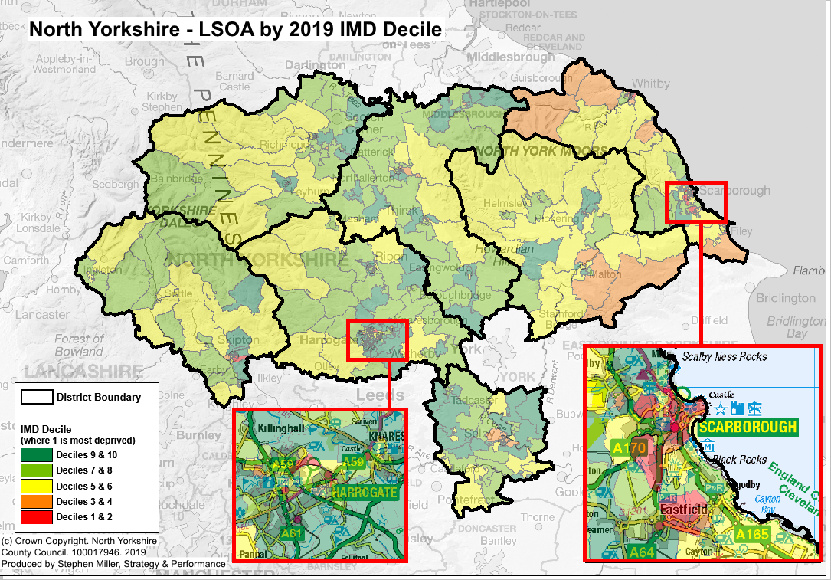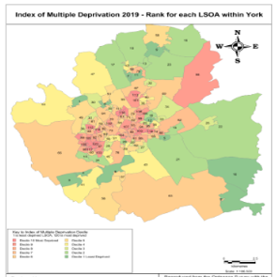

Comparing to the wider picture, and reflecting the overall low levels of deprivation in many part of the county, nearly all of the lower-teir authorities in the area are in the less-deprive half LAs nationally. However, Scarborough in particular falls into the 25% most deprived LAs nationally.

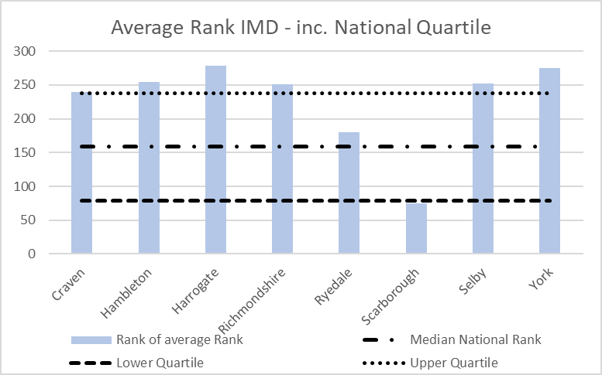

Reflective of York & North Yorkshire’s overall affluency, a majroity of Districts/Boroughs (inc. York) are less income deprived than the ‘median’ lower-teir authority. The exception to this is Scarborough, which sits on the cusp of falling into the 25% most income deprived two-teir authorities natioanlly.

The rising cost of living comes at a time when food bank useage across the Yorkshire & Humber region is reaching record heights. During 2021/22 over 156,000 people accesses a food bank in Yorkshire & Humber, according to Trussell Trust figures - which do not include information on all Food banks including those in Craven, Hambleton, Richmondshire, or Scarborough so the actual figure is likely to be much higher.

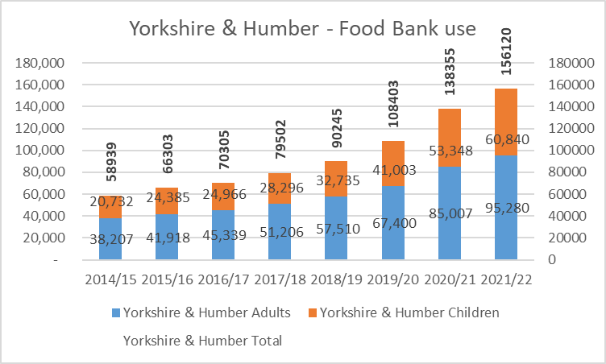

Looking at a smaller geographical level, for the areas in YNY that Trussell Trust provides data form, we can see that whilst Food Bank use in Selby and Ryedale has considerably reduced, Food Bank use in both Harrogate and York is increasing.

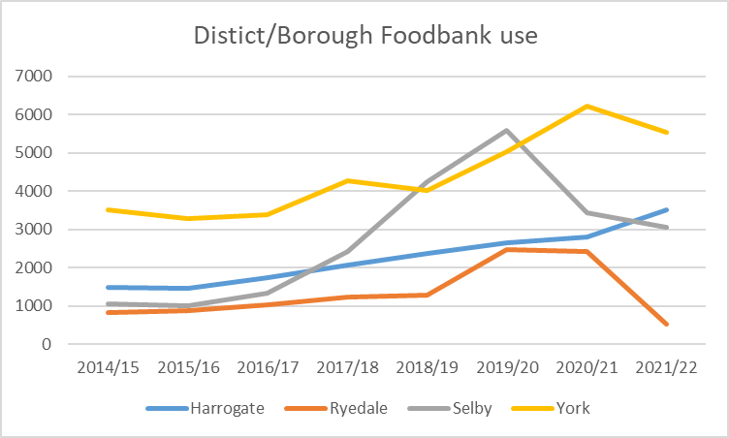

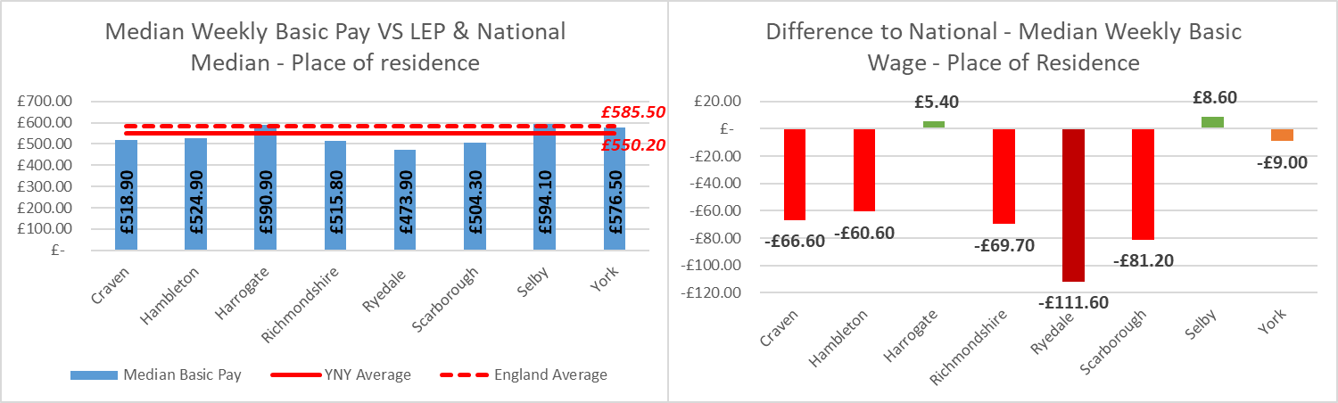The charts below show the median weekly basic wage compared to the LEP and National median wage, alongside the difference to the national wage. Whilst the median wage in Harrogate and Selby are both slightly higher than the national median wage, across the remainder of the YNY area, there is a significant deficit compared to the national median, ranging from -£60.60 in Ryedale to -£111.60 in Ryedale.

1. Innovative numeracy programmes delivered together with employers – LEP research on employer skills needs

There is a skills gap across both York and North Yorkshire. Whilst as a proportion of the population of employees (Figure 87) this isn’t particularly at odds with the national rate (~4.5%), there are notable Skills Gaps across the LEP (figure 88), does show prevalent gaps in a number of key industry sectors, notably Manufacturing , Hotels & retail, Public admin, Financial Services and Wholesale and Retail. Whilst in the long-term it is forecast that some of these areas may see a decline, in the short-term functional maths skills through the multiply project will help to close the skills gap and increase upwards mobility.

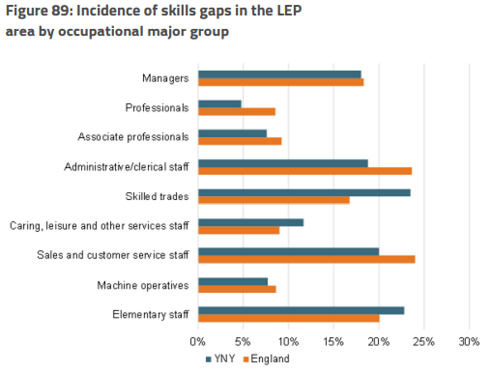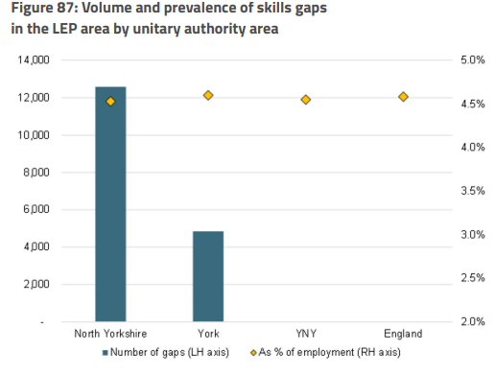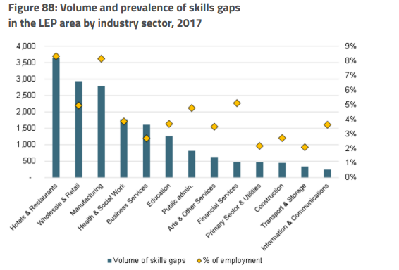

Looking at the skills gap by occupational group (figure 89), there are some clear areas where YNY sees a skills gap. Skilled Trades, lower-skilled elementary staff, sales and customer service and administrative staff all see notable larger deficits than national. Functional Skills may act as either a gateway into these occupations for low or unqualified applicants, whilst acting as a gateway to a career path into the more skilled trades.

Given the skills gap in certain sectors, there is the opportunity there to look at options for joint-delivery to upkill the workforce, potentially closing these skill gaps. Functional Maths through the multiply could be a cornerstone of this.

1. Courses aimed at people who can’t apply for certain jobs because of lack of numeracy skills and/or to encourage people to upskill in numeracy order to access a certain job/career. As above but also will need employment and unemployment trends

The table below show the four biggest sectors in the York & North Yorkshire LEP (YNY). Based on the Working Futures Study, the sector with the lowest prospects is Manufacturing, forecast to see a 10% reduction in employment by 2027. With Manufacturing forecast to see a significant decrease by 2027, some districts (such Selby and Ryedale) are considerably more vulnerable with between 1 in 4 and 1 in 5 workers employed in the manufacturing sector.

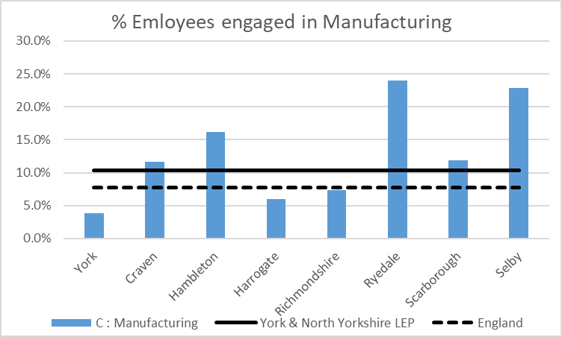

The chart below shows the proportion of the YNY workforce employed by sectors that are forecast to see growth or decline by 2027. Across the LEP, over have of employees are engaged in sectors that will see decline, increasing in Hambleton, Ryedale and Selby. Given the importance of functional numeracy in developing reasoning and logical thinking skills, it is key to unlocking people’s potential to adapt to an increasing skilled-sector led marker.

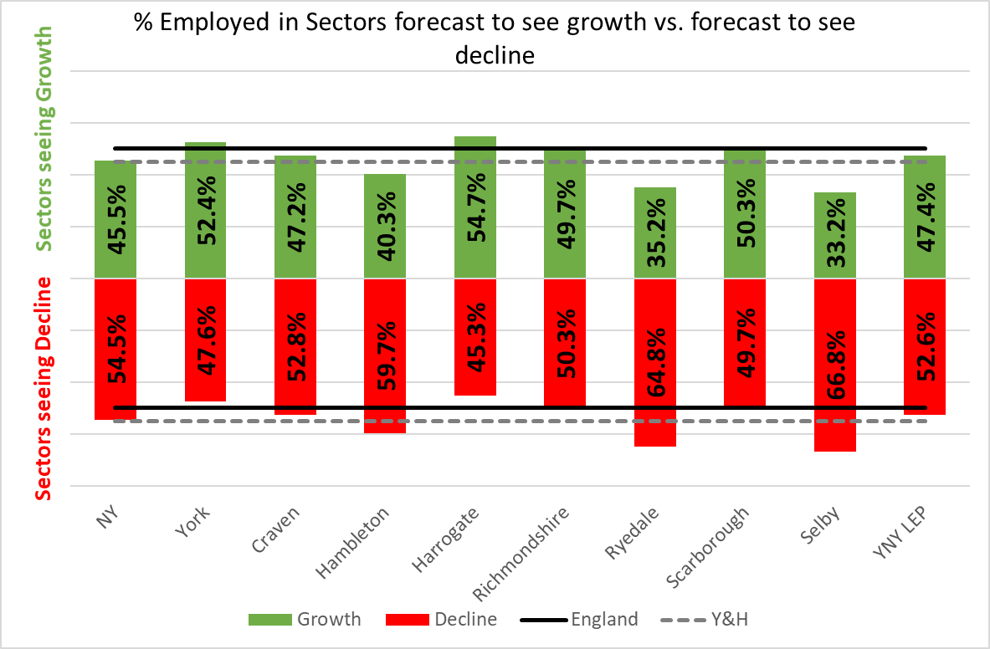

Given the vulnerability of the workforce in LEP as a whole (1 in 10 employed in Manufacturing, and over half in sectors that are forecast to see decline) and certain Districts more specifically in terms of future-proofing employment and skills, improving functional numeracy has the potential to become a cornerstone for upskilling the workforce. Reflective of a need to upskill the workforce, around two-thirds of employers have upskilling needs in the LEP, with functional numeracy skills being highlighted as an area for development.

According to data from NOMIS – all areas of the LEP (with the exception of Craven) have a higher unemployment rate currently than the wider LEP average – based on model-based estimates.

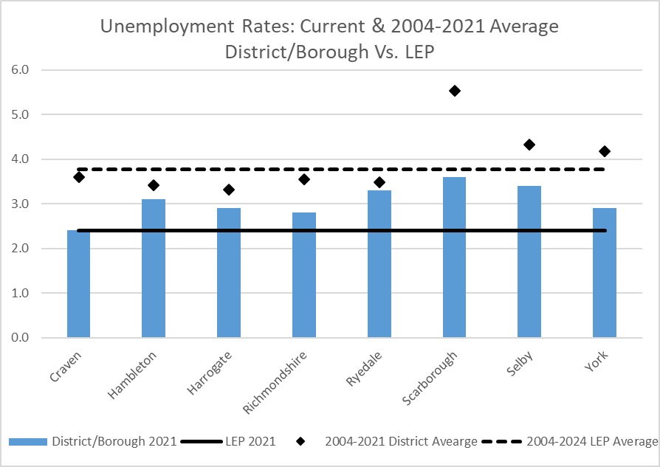

1. New intensive and flexible numeracy courses targeted at people without Level 2 maths, leading to a Functional Skills Qualification. Likely to be the school exit data and qualification level information from census, (will be slightly flawed due to widening participation at university and due to net migration out of region by young people)

Schools data as highest level of Qualification include against point 1.

Whilst across the YNY LEP is ranked second in the north in the proportion of people qualified to at least level 2, at a district level, the need for localised ‘levelling up’ is clear, with Ryedale and Selby all lagging behind the national rate in terms of 16 to 64 year old qualified to NVQ Level 1 or higher. Scarborough just hits the national average, whilst all other areas have notable higher rates than the national average.



1. Courses for parents wanting to increase their numeracy skills in order to help their children, and help with their own progression. School output data at key stages in numeracy, likely down at granular level

As the data including in Q1 highlights, there is a varying picture in regards to Maths at KS4, with some areas of YNY area performing notably below the national average. The two tables below show the Maths trend since 2016 at Key Stage 1 and Key Stage 2. The maths outcomes in Scarborough are consistently lower than the national at both Key Stage 1 (National: 75.6% / Scarborough: 68.3%) and Key Stage 2 (National: 78.7% / Scarborough: 70.6%). Ryedale also consistently underperforms compared to other areas and the national average. With this in mind, it is worth noting that both Scarborough and Ryedale are areas where the working age population are more likely to be less qualified that elsewhere in the region. In turn, this is likely to be mean that parents are less well-equipped to support children with early numeracy, impacted long-term achievement.

|  |  |  |  |  |
| --- | --- | --- | --- | --- |
| **Key Stage 1 Maths Trend** | Expected standard or above | Expected standard or above | Expected standard or above | Expected standard or above |
| 2016 | 2017 | 2018 | 2019 |
| Craven | 73.5% | 76.7% | 73.7% | 76.6% |
| Hambleton | 72.4% | 75.4% | 74.0% | 74.3% |
| Harrogate | 74.6% | 75.2% | 78.7% | 76.8% |
| Richmond | 68.8% | 77.2% | 77.2% | 76.9% |
| Ryedale | 68.2% | 73.7% | 71.3% | 68.7% |
| Scarborough | 63.6% | 68.4% | 70.3% | 68.3% |
| Selby | 69.4% | 73.9% | 76.4% | 76.9% |
| North Yorkshire | 70.4% | 74.1% | 75.0% | 74.3% |
| York | 71.0% | 77.0% | 77.0% | 77.0% |
| National | 72.6% | 75.1% | 76.0% | 75.6% |

|  |  |  |  |  |
| --- | --- | --- | --- | --- |
| **Key Stage 2 Maths trend** | Expected standard or above | Expected standard or above | Expected standard or above | Expected standard or above |
| 2016 | 2017 | 2018 | 2019 |
| Craven | 70.2% | 71.5% | 70.5% | 73.5% |
| Hambleton | 63.4% | 73.7% | 69.7% | 74.8% |
| Harrogate | 73.1% | 76.2% | 75.3% | 80.3% |
| Richmond | 62.9% | 71.1% | 64.3% | 73.5% |
| Ryedale | 63.5% | 72.5% | 72.5% | 80.1% |
| Scarborough | 59.5% | 64.8% | 70.0% | 70.6% |
| Selby | 65.1% | 70.1% | 76.4% | 80.8% |
| North Yorkshire | 66.2% | 71.7% | 72.2% | 76.7% |
| York | 69.0% | 76.0% | 77.0% | 82.0% |
| National | 69.8% | 74.9% | 75.5% | 78.7% |

1. Numeracy courses aimed at prisoners, those recently released from prison or on temporary licence. Prison population and re-offending data again at granular level

Re-offending:

The chart below shows the latest proven re-offending rate by lower-tier authority in the area. There are 2 areas that particularly stand out in terms of high re-offending rates compared to the average rate across the York & North Yorkshire area (22.1%). These are York (30.7%) and Scarborough (36.4%). Whilst the overall the YNY average is lower than the national average (25.8%), York and Scarborough both have higher rates of re-offending.

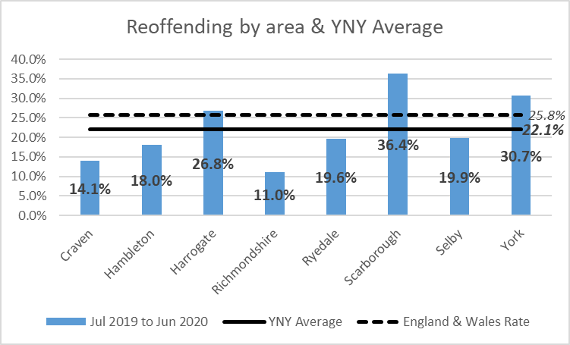

Current Prison Population in North Yorkshire:

* Askham Grange: 82
* Kirklevington Grange: 177

In terms of performance against the ambition that those released from Prisons in North Yorkshire varies. As the chart below, Askham Grange performs better in terms of persons in employment at 6 weeks following release (36.2% / target: 32.9%), compared to Kirklevington Grange (31.8% / target: 37.6%). Whilst this is, on paper, better performance, the facts are that roughly 2 in every 3 prisoners release fail to enter employment within 6 weeks of their release from prison.

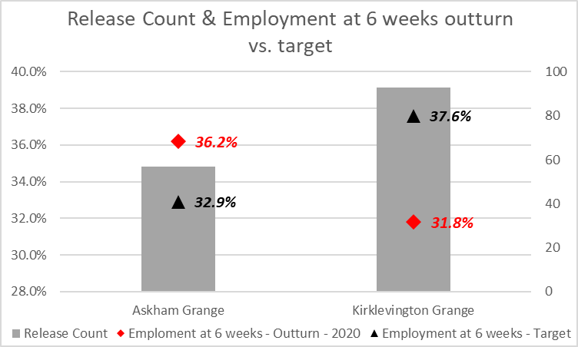

1. Numeracy courses aimed at those 19 or over that are leaving, or have just left, the care system

There are currently 281 young people aged 19 to 25 supported by North Yorkshire’s Leaving Care Service, of whist 39 are NEET due to illness, 19 are NEET due to parenting or pregnancy and 42 are NEET due to ‘other’ circumstances. We know that the academic outcomes for Children in Care are considerably lower than their non-Looked After peers, therefore the offer of functional maths skills may have a significant impact to improving long-term outcomes for this cohort. For example in 2018, just 17.5% of Children in Care for over 12 months achieved grade 4 to 9 in English and Maths, compared to 68.4% of all children in North Yorkshire.

The map below provides an overview of the location of NY Care Leavers that are currently NEET due to ‘other circumstances’.

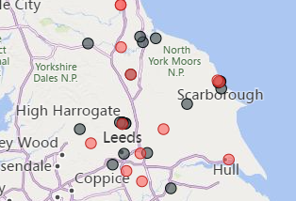

In addition to the North Yorkshire cohort, there are an additional 96 Care Leavers supported by York City Council over the are of 19, of which 20 (20.8%) are currently NEET.

The opportunities for engaging Care Leavers isn’t restricted to promoting ETE, but could also help in terms of providing budgeting skills and wider numerical life skills that many of us are taught as part of a settled family life.

1. Numeracy activities, courses or provision developed in partnership with community organisations and other partners aimed at engaging the hardest to reach learners
2. Additional relevant maths modules embedded into other vocational courses.