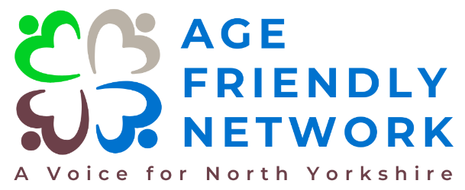
Volunteer Community Action Partners

The Age Friendly Network is a project that is really starting to take shape, and we are now looking ahead to build on our vision and further develop the network.
Can you help us? We seek to engage with people who are passionate about improving the physical and social environments of communities throughout North Yorkshire and we have developed a number of exciting volunteer opportunities to help really make a difference now and in the future.
Position: Community Action Partners
Location: North Yorkshire (Various Locations)
Commitment: Part-Time (Flexible Hours)
The Role
Community Action Partners will represent the voice of older people and help transform our communities!!
As a Community Action Partner, you will be the eyes, ears, and voice of your community within the Age Friendly Network. Your role is crucial in identifying the unique needs and opportunities within your local area, helping to shape and implement initiatives that make a real difference. You’ll work closely with other community members, local organisations, and our charity to drive positive change and create a thriving, age-friendly environment where everyone feels welcome.

Key Responsibilities:
Local advocacy - Represent the views and needs of older adults in your community, ensuring their voices are heard in all decision-making processes. Keeping up to date with other communities throughout the county and ensuring representation is diverse, inclusive and impartial.
Community engagement - Build strong relationships with residents, local groups, and organisations to foster a sense of community, trust, collaboration and openness.
Initiative development - Identify opportunities for community-based projects and initiatives that support the well-being and inclusion of older adults.
Awareness building - Help raise awareness about the Age Friendly Network and its goals, encouraging more people to get involved and support the further development of the network and our mission to make North Yorkshire and ‘All’ Age Friendly place.
Feedback and reporting - Provide regular feedback to the Age Friendly Network on the challenges and successes within your community, helping to shape our broader strategy.
Training - Participate in training sessions to develop skills required for the role.

Why volunteer with us?
Make a real impact - Your contributions will directly influence the quality of life for older adults in North Yorkshire.
Develop new skills - Gain valuable experience in charity governance, strategic planning, and leadership.
Collaborate with passionate people - Work alongside a team of dedicated individuals who share your commitment to positive change.
Flexible commitment - We understand the importance of work-life balance and there is full flexibility in terms of your time commitment.
Support – You will have the full, ongoing support of the Project Coordinator, the Project Steering Group and Community First Yorkshire.
How to apply
If this sounds like something you would be interested in becoming involved with, we would love to hear from you! Please send an email explaining why you want to volunteer and what skills you will bring to the role to helen.hunter@communityfirstyorkshire.co.uk If you wish to send it by post, please send to Helen Hunter at Community First Yorkshire, Unit A, Tower House, Askham Fields Lane, Askham Bryan, York, YO23 3FS.
If you wish to have an informal chat about the role, please don’t hesitate to contact Helen, our Age Friendly Network Development Officer, on 07519 127561.
Thank you!

