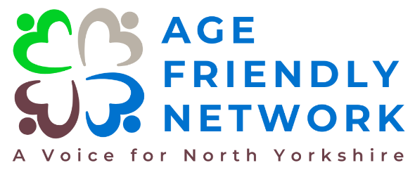
Volunteer Reporter

The Age Friendly Network is a project that is really starting to take shape, and we are now looking ahead to build on our vision and further develop the network.
Can you help us? We seek to engage with people who are passionate about improving the physical and social environments of communities throughout North Yorkshire and we have developed a number of exciting volunteer opportunities to help really make a difference now and in the future.
Position: Volunteer Reporter
Location: North Yorkshire (Various Locations)
Commitment: Part-Time (Flexible Hours)
The Role
Our Reporters will help ‘tell the story of our community’!
We are looking for passionate and talented individuals to take the lead on our regular Newsletter, your insights, ideas and lived experience will help shape the future of this publication, you will contribute to the development of regular features and help us to really bring our Newsletter to life!!
As a Volunteer Reporter, you will play a key role in gathering and sharing local knowledge and information that resonates with our members. You will work closely with local organisations, groups, and authorities to ensure our newsletter is not only accurate and informative but also entertaining and engaging. Your work will help us connect with our communities, providing valuable insights and updates through a well-crafted newsletter that reaches a wide audience across North Yorkshire. Whether distributed by email, post, or in public spaces for example; libraries and GP surgeries, your contributions will make a significant impact on how we communicate and connect with our members.
We are seeking volunteers who are passionate about storytelling and have a strong connection to their community. Ideal candidates will have:
- Strong Writing Skills - A flair for writing engaging, accurate, and clear content that appeals to a wide audience.
- Local Knowledge - A deep understanding of your local area, including key events, issues, and community dynamics.
- Communication Skills - The ability to interact with a variety of people, from local authorities to community groups.

Key Responsibilities:
Content - Collect news, stories, event details and updates from local communities, organisations, groups, and authorities.
Newsletter production - Write and edit articles, ensuring they are accurate, engaging, and representative of our community – diversity and inclusion will key to this aspect of the role. Contribute ideas for new features, sections, and formats for the newsletter, including exploring audio formats to make our content more accessible.
Collaboration - Work with local councillors, organisations, and other community members to gather content, news articles and insights.
Distribution support - Assist in the distribution of the newsletter, ensuring it reaches members through email, printed copies, and public outlets.
Team meetings - Attend regular meetings with fellow reporters to share ideas, ensure consistency, and maintain professionalism in all content produced.
Training - Participate in training sessions to develop skills in journalism, content creation, and community reporting.

Why volunteer with us?
Make a real impact - Your contributions will directly influence the quality of life for older adults in North Yorkshire.
Develop new skills - Gain valuable experience in charity governance, strategic planning, and leadership.
Collaborate with passionate people - Work alongside a team of dedicated individuals who share your commitment to positive change.
Flexible commitment - We understand the importance of work-life balance and there is full flexibility in terms of your time commitment.
Support – You will have the full, ongoing support of the Project Coordinator, the Project Steering Group and Community First Yorkshire.
How to apply
If this sounds like something you would be interested in becoming involved with, we would love to hear from you! Please send an email explaining why you want to volunteer and what skills you will bring to the role to helen.hunter@communityfirstyorkshire.co.uk If you wish to send it by post, please send to Helen Hunter at Community First Yorkshire, Unit A, Tower House, Askham Fields Lane, Askham Bryan, York, YO23 3FS.
If you wish to have an informal chat about the role, please don’t hesitate to contact Helen, our Age Friendly Network Development Officer, on 07519 127561.
Thank you!

